**Task 1.3**

1. **In your Anaconda prompt, create a new virtual environment and give it the title “20th_century”. Take a screenshot of the terminal and paste it into a word processing document.**

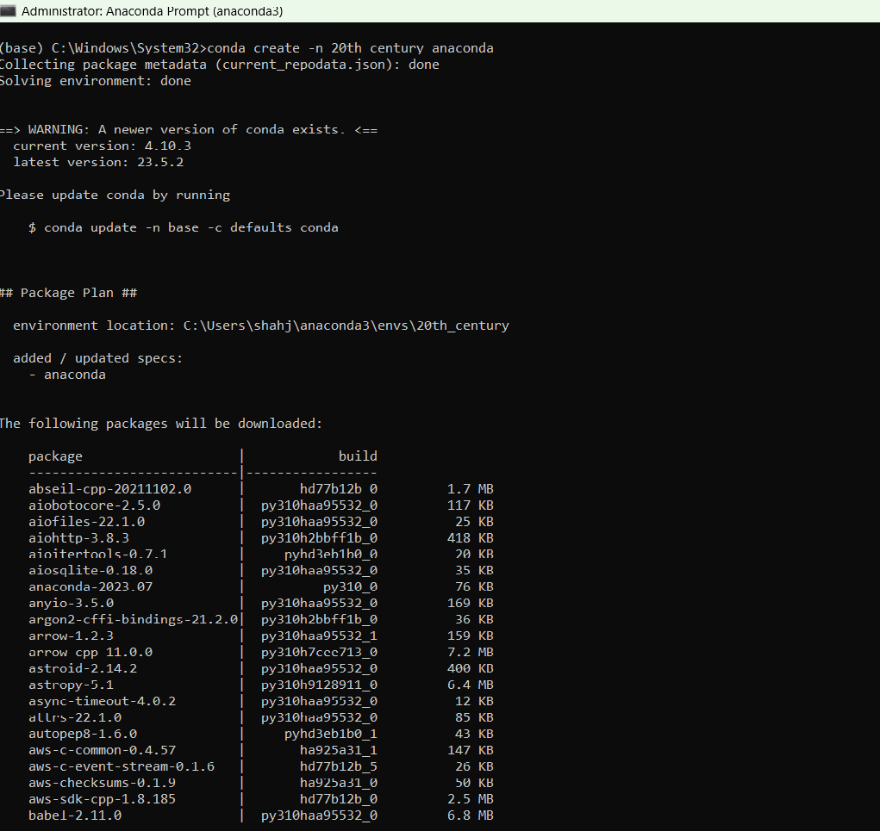

1. **Activate your virtual environment and take a screenshot to confirm that this step is complete. Paste the screenshot into your word processing document.**

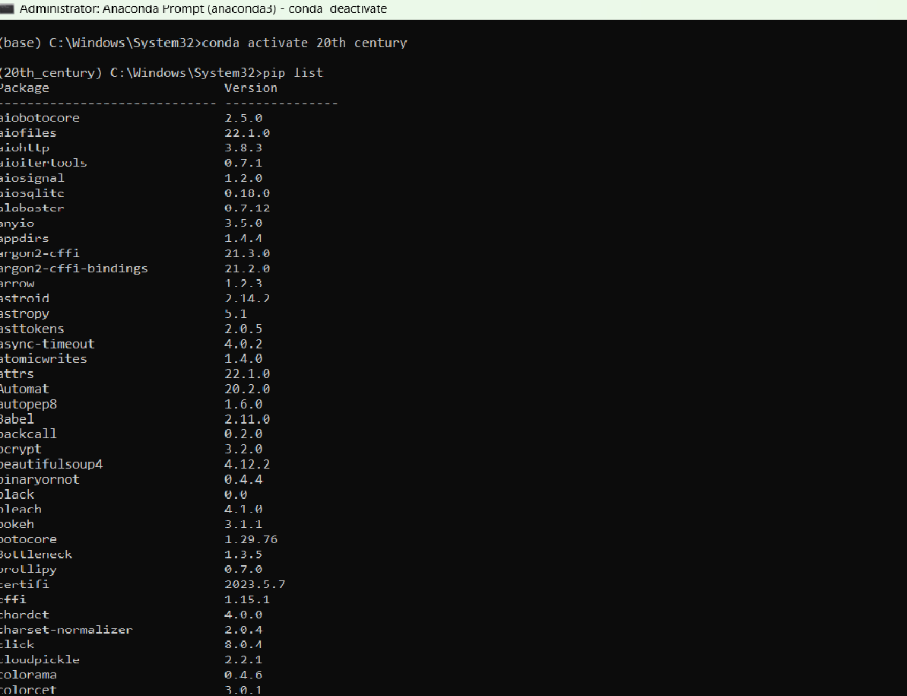

1. **Install the ipykernel library inside the virtual environment.**

Conda install ipykernel

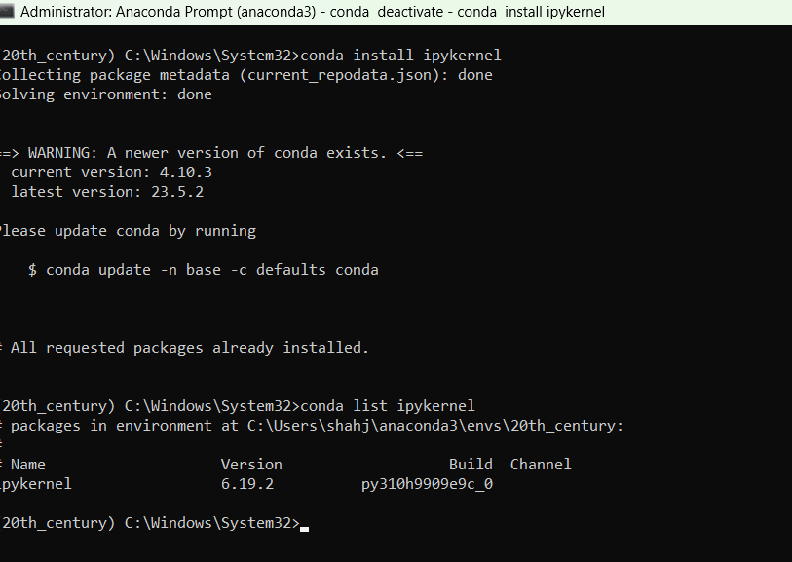

1. **Deactivate the environment and launch JupyterLab from the base. Once JupyterLab has opened in the browser, create a new notebook and select the “20th_century” environment from the list of kernels. Before closing the window, take a screenshot of the prompt and place it in your word processing document.**

